Combustion based spud cannon
Material required-
- 0.6MPa pressure rated pipe for barrel. Dia can be varied from 1’’-1.5’’ length-at least 1m
- MTA-FTA(male/female threaded adapter, same dia as pipe) pair for a screw-in barrel.
- Pressure rated 3’’ -4’’ pipe for combustion chamber.(calculate length that is needed to make 2L combustion chamber)
- MTA and a end cap(same dia as pipe) for one end of combustion chamber.
- Connector : 3’’-4’’ pipe to 1’’-1.5’’ pipe.
- Epoxy adhesive for all joints eg- araldite, pvc solvent cement tube etc
- Kitchen gas lighter with or without AA cell.(any will work)
- Deodorant bottle (ensure that the deo doesn’t have any water percentage in it )
- A 20x20cm cloth strip to make a roll out of that as a projectile.

Setup figure –
The screw-in barrel-
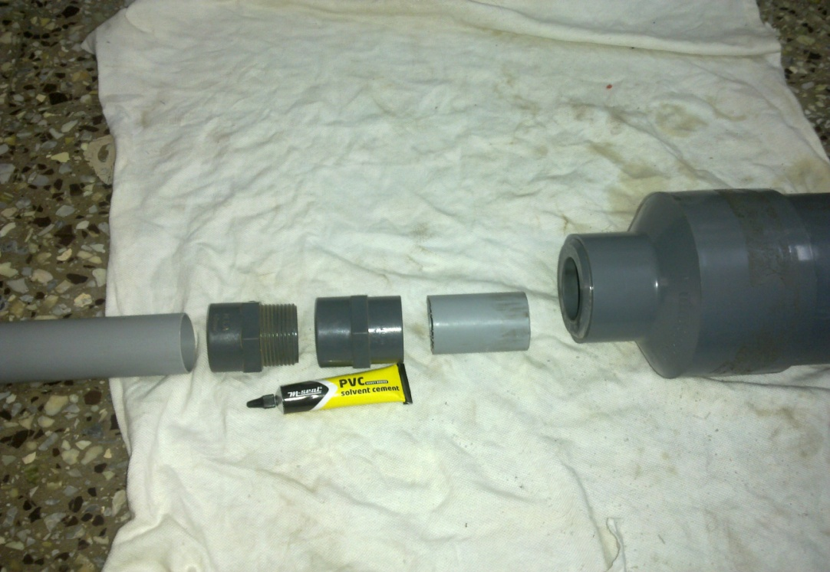
From left-
Barrel pipe40mm – MTA-FTA-piece of pipe-bushing63mm-40mm-connector110mm-63mm-110mm pipe(4’’ combustion chamber)
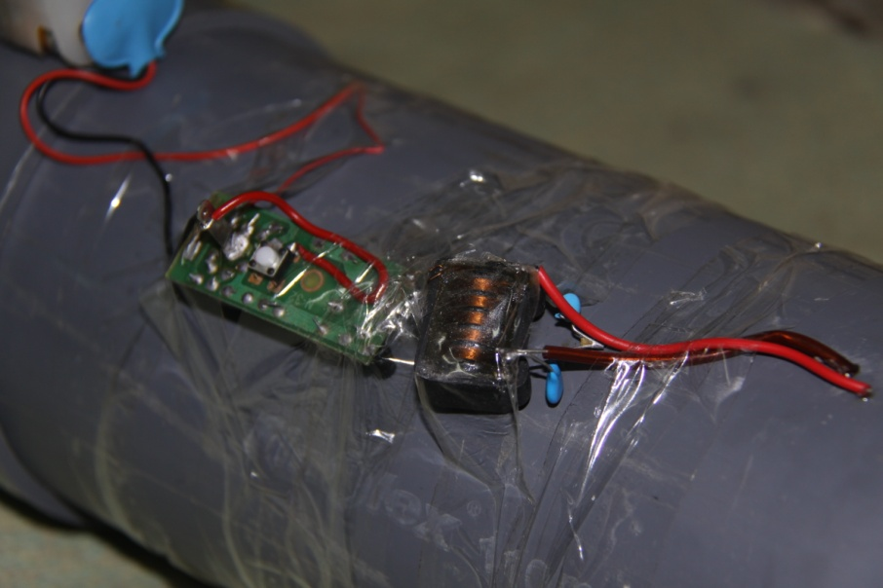
The circuit obtained from cell powered kitchen gas lighter. 4AA cells are put instead of 1 cell for stronger sparking.
A normal gas lighter also can be used for sparking purpose. Take out two wires from central electrode and outer body. Put an insulation tape between electrodes so that sparking doesn’t occur in the lighter body. Check that sparking occurs at the end of wires.
Keep 2-4mm dist between wires for efficient sparking.
Final gun-
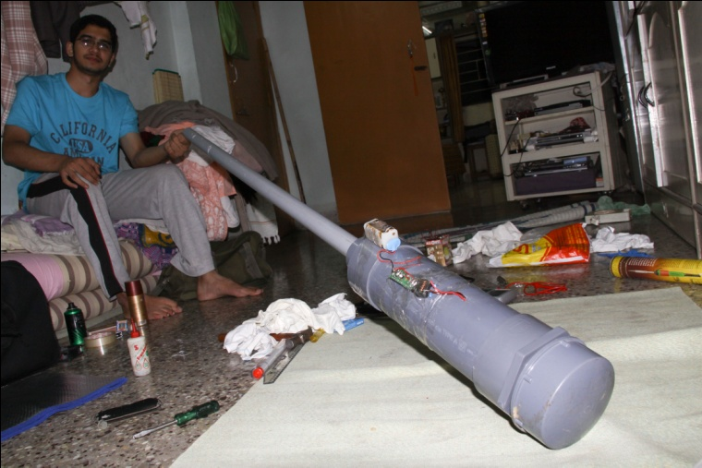

Fix all the joints with epoxy adhesive and wait till the adhesive sets completely. Else! -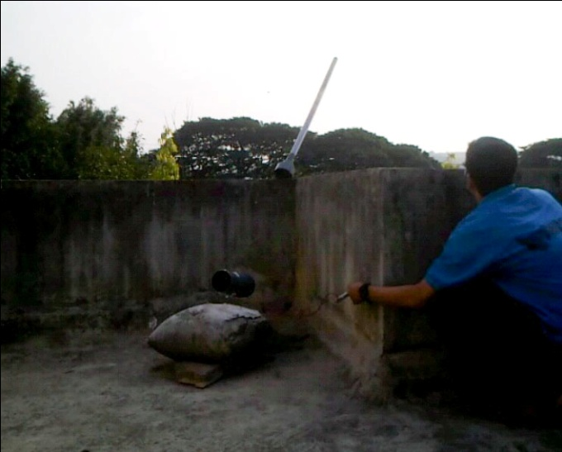

Important notes:

- The combustion chamber shown in above photos is much larger. Keep the volume restricted to 2L
- Do not test the gun indoors.
- Keep the trigger away from the gun so that in case of any misfire of explosion of pipe, u are safe !
- Use only pressure rated pipes. Schedule40 pipes will do.
- Recycle the air inside combustion chamber after each shot.

