Cannon Shooting Mechanisms

- Spring Mechanisms
This category contains systems based on mechanical stored energy in a spring. This system is very simple mechanism. A spring is wound up, held and released at certain moment of time. Varying from basic spring systems to cross-bow based mechanisms. Figure 1 contains a simplified model of a standard spring mechanism.
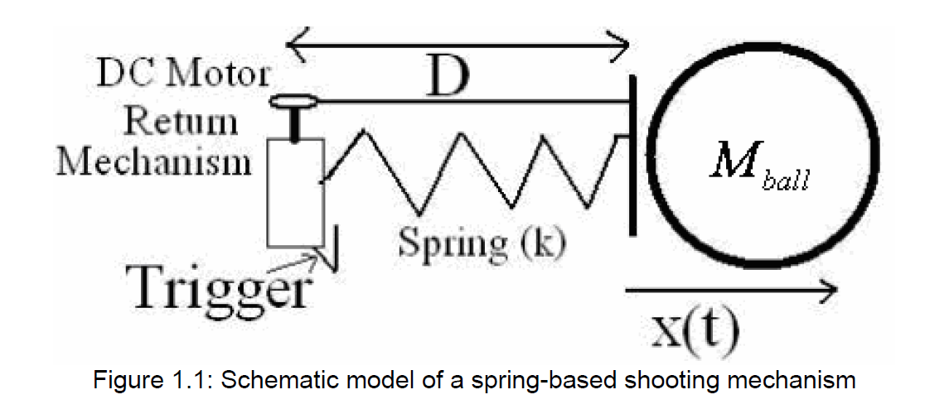

For this simple model, the equation of motion holds.
$$m_{ball}\ddot{x=}-kx$$
With initial values
$$x\left(0\right)=D$$
$$\frac{dx}{dt}( at t=0)=0$$

- Solenoid Based Mechanism
Shooting devices also work on the principle of self-inductance. By sending a current trough a turn of wire, a magnetic field can be built. As the number of turn or current increases, the magnetic field increases too. With magnetism, ferromagnetic materials can be attracted or repulsed. This phenomenon is used in a solenoid. Solenoid can prove as a powerful and silent ball shooter. A schematic diagram can be found below:
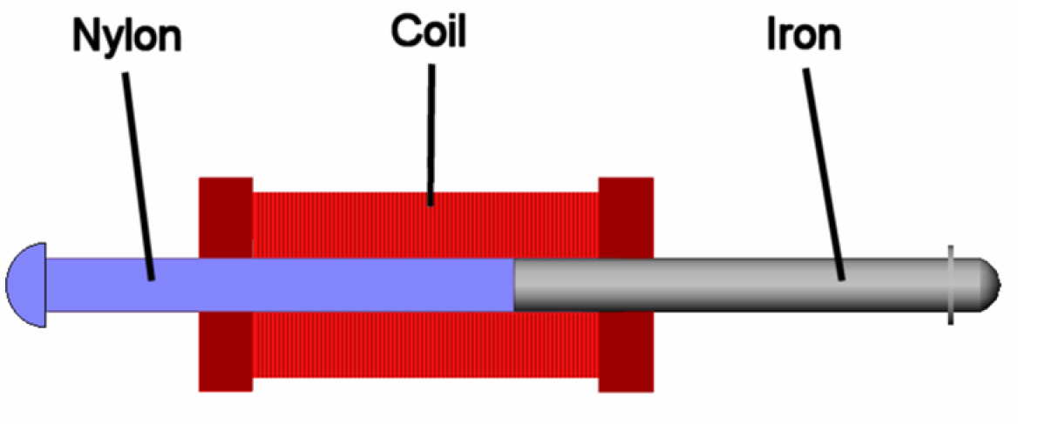
Figure 2: Solenoid shooting mechanism
This design takes advantage of the property that a solenoid has a ferromagnetic core which is attracted into the coil centre. The piece of nylon which is attached to the iron bar is a non-ferro and shoots outwards and hits the ball.

- Rack and Pinion Mechanism
This is yet another type of mechanism for shooting a ball. The schematic diagram given below explains it:
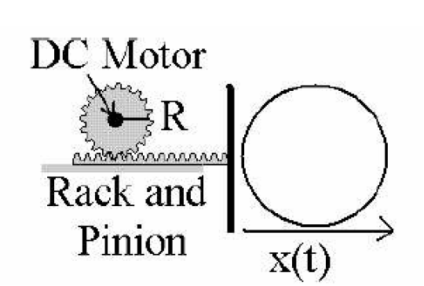

- Coil gun Mechanism
The figure illustrates how a simple coil gun mechanism works to shoot a projectile. The same mechanism can be used with some modifications to suit our purpose.

